TM


OPC Alarms and Events Samples
Preliminary Draft
Version 0.02

Synopsis:
This specification is the specification of the interface for developers of OPC clients and OPC servers.. The specification is a result of an analysis and design process to develop a standard interface to facilitate the development of servers and clients by multiple vendors that shall inter-operate seamlessly together.
Specification Type | Industry Standard Specification
Title: | OPC Alarms and Events Samples | Date: | July 13, 1998
Version: | 0.02 | Soft | MS-Word
 |  | Source: | 0000.doc
Author: | Opc Foundation | Status: | Preliminary Draft

Trademarks:
Most computer and software brand names have trademarks or registered trademarks. The individual trademarks have not been listed here.

Required Runtime Environment:

This specification requires Windows 95 Windows NT 4.0 or later

NON-EXCLUSIVE LICENSE AGREEMENT

The OPC Foundation, a non-profit corporation (the “OPC Foundation”), has established a set of standard OLE/COM interface protocols intended to foster greater interoperability between automation/control applications, field systems/devices, and business/office applications in the process control industry.

The current OPC specifications, prototype software examples and related documentation (collectively, the “OPC Materials”), form a set of standard OLE/COM interface protocols based upon the functional requirements of Microsoft’s OLE/COM technology. Such technology defines standard objects, methods, and properties for servers of real-time information like distributed process systems, programmable logic controllers, smart field devices and analyzers in order to communicate the information that such servers contain to standard OLE/COM compliant technologies enabled devices (e.g., servers, applications, etc.).

The OPC Foundation will grant to you (the “User”), whether an individual or legal entity, a license to use, and provide User with a copy of, the current version of the OPC Materials so long as User abides by the terms contained in this Non-Exclusive License Agreement (“Agreement”). If User does not agree to the terms and conditions contained in this Agreement, the OPC Materials may not be used, and all copies (in all formats) of such materials in User’s possession must either be destroyed or returned to the OPC Foundation. By using the OPC Materials, User (including any employees and agents of User) agrees to be bound by the terms of this Agreement.

LICENSE GRANT:

Subject to the terms and conditions of this Agreement, the OPC Foundation hereby grants to User a non-exclusive, royalty-free, limited license to use, copy, display and distribute the OPC Materials in order to make, use, sell or otherwise distribute any products and/or product literature that are compliant with the standards included in the OPC Materials.

All copies of the OPC Materials made and/or distributed by User must include all copyright and other proprietary rights notices include on or in the copy of such materials provided to User by the OPC Foundation.

The OPC Foundation shall retain all right, title and interest (including, without limitation, the copyrights) in the OPC Materials, subject to the limited license granted to User under this Agreement.

WARRANTY AND LIABILITY DISCLAIMERS:

User acknowledges that the OPC Foundation has provided the OPC Materials for informational purposes only in order to help User understand Microsoft’s OLE/COM technology. THE OPC MATERIALS ARE PROVIDED “AS IS” WITHOUT WARRANTY OF ANY KIND, EXPRESS OR IMPLIED, INCLUDING, BUT NOT LIMITED TO, WARRANTIES OF PERFORMANCE, MERCHANTABILITY, FITNESS FOR A PARTICULAR PURPOSE OR NON-INFRINGEMENT. USER BEARS ALL RISK RELATING TO QUALITY, DESIGN, USE AND PERFORMANCE OF THE OPC MATERIALS. The OPC Foundation and its members do not warrant that the OPC Materials, their design or their use will meet User’s requirements, operate without interruption or be error free.

IN NO EVENT SHALL THE OPC FOUNDATION, ITS MEMBERS, OR ANY THIRD PARTY BE LIABLE FOR ANY COSTS, EXPENSES, LOSSES, DAMAGES (INCLUDING, BUT NOT LIMITED TO, DIRECT, INDIRECT, CONSEQUENTIAL, INCIDENTAL, SPECIAL OR PUNITIVE DAMAGES) OR INJURIES INCURRED BY USER OR ANY THIRD PARTY AS A RESULT OF THIS AGREEMENT OR ANY USE OF THE OPC MATERIALS.

GENERAL PROVISIONS:

This Agreement and User’s license to the OPC Materials shall be terminated (a) by User ceasing all use of the OPC Materials, (b) by User obtaining a superseding version of the OPC Materials, or (c) by the OPC Foundation, at its option, if User commits a material breach hereof. Upon any termination of this Agreement, User shall immediately cease all use of the OPC Materials, destroy all copies thereof then in its possession and take such other actions as the OPC Foundation may reasonably request to ensure that no copies of the OPC Materials licensed under this Agreement remain in its possession.

User shall not export or re-export the OPC Materials or any product produced directly by the use thereof to any person or destination that is not authorized to receive them under the export control laws and regulations of the United States.

The Software and Documentation are provided with Restricted Rights. Use, duplication or disclosure by the U.S. government is subject to restrictions as set forth in (a) this Agreement pursuant to DFARs 227.7202-3(a); (b) subparagraph (c)(1)(i) of the Rights in Technical Data and Computer Software clause at DFARs 252.227-7013; or (c) the Commercial Computer Software Restricted Rights clause at FAR 52.227-19 subdivision (c)(1) and (2), as applicable. Contractor/ manufacturer is the OPC Foundation, P.O. Box 140524, Austin, Texas 78714-0524.

Should any provision of this Agreement be held to be void, invalid, unenforceable or illegal by a court, the validity and enforceability of the other provisions shall not be affected thereby.

This Agreement shall be governed by and construed under the laws of the State of Minnesota, excluding its choice or law rules.

This Agreement embodies the entire understanding between the parties with respect to, and supersedes any prior understanding or agreement (oral or written) relating to, the OPC Materials.

Table of Contents
1. Introduction 1
1.1 Relationship to OPC Specifications 1
2. Installation 2
3. Sample Server 3
3.1. Overview 3
3.2. Running the Server 3
3.3. Editing the Simulation File 3
3.3.1. Areas Column 4
3.3.2. Attribute Columns 4
3.4. Registry Settings 4
3.5. Source Code 4
4. Sample Client 5
4.1. Overview 5
4.2. Running the Client 5
4.2.1. Connect 5
4.2.2. Event Subscription 6
4.2.3. Get Status 6
4.2.4. Language 7
4.2.5. Browser 7
4.2.6. Filter 8
4.2.7. Attributes 8
4.3. Source Code 9
5. Proxy/Stub 10

Introduction
This document contains information about the custom client and server applications that the OPC Foundation provides as a companion to the Alarm and Events Custom Interface Specification. The samples are provided complete with source code, hence this document provides information down the to the source code level. The OPC Foundation has produced these samples for two reasons:
- To prove that the specification as written can be implemented.
- To serve as a guide for Foundation Members that choose to provide implementations of their own.

Relationship to OPC Specifications
This document and the sample code described herein conforms to the OPC Alarm & Events Specification 1.0.

Installation
An installation program (SETUP.EXE) is provided that installs the executables and source code to a user specified directory. The installation will properly register the Sample Server and the two proxy/stub DLLs. These files are place in the root installation directory:
OPCAESamples.doc | This document
OPC_AE_SampleServer.csv | Simulation file read by the Sample Server
OPC_AE_SampleServer.exe | Sample Server executable
opc_aeps.dll | OPC Alarm & Events proxy/stub DLL.
OPC_Comnps.dll | OPC Common proxy/stub DLL.
SampleClient.exe | Sample Client executable.
Uninst.isu | Installshield uninstall file.

The subdirectories of the installation directory contain the source code for each of the executables.

Sample Server

Overview
The Sample Server (OPC_AE_SampleServer.exe) simulates alarms and events by reading data from a comma separated data (CSV) file. Each record in the CSV file represents a single instance of an event. The Sample Server reads and processes each record at a fixed rate and produces a corresponding OPC Event Notification for its attached clients.
The Sample Server is written in C++ and requires MSVC 5.0 with Visual Studio Service Pack 3 or higher to build. It makes extensive use of ATL (Active Template Library) and STL (Standard Template Library). The server has no user interface.
The only optional method not implemented by the Sample Server is IOPCEventServer::TranslateToItemIDs.

Running the Server
In order to run properly, the server and the proxy/stub DLLs need to be registered. This is done for you by the installation program, but here is how to do in manually if you need to. From the command line run:

OPC_AESampleServer.exe /RegServer
regsvr32 opc_aeps.dll
regsvr32 opccomn_ps.dll
The server is typically launched automatically when a client requests it. Except for debugging, there is no reason launch the server manually, it has no user interface.
Note. Each time the server is launched manually a new copy is started. Each time a new client requests the server, the client will attach to an existing server if one is running. If extra copies get executed by mistake, use the task manager to kill them
The sample server opens and reads the CSV file that must be located in the same directory as itself. The CSV file must have the same base name as the server (i.e. OPC_AESampleServer). When executed, the server reads and processes all of the records in the CSV file once then rewinds the file and begins processing the records again at a rate that is controlled by a registry setting (default is one record every five seconds). The file is processed repeatedly at this controlled rate until the server is terminated.

Editing the Simulation File
The simulation file (OPC_AESampleServer.csv) may be edited to create simulated data to emulate many different scenarios. Although the CSV file can be edited directly, it is recommended that the native Excel (XLS) file be edited and saved as a CSV file for input to the Sample Server. The XLS file (OPC_AESampleServer.xls) can be found in the source directory for the Sample Server (AlarmEvents\SampleServer)
The column headings in the file are mostly self-explanatory and match the nomenclature used in the OPC Alarm & Events Specification.
Note. The proper operation of the server relies on both the column order and the column headings. Please do not alter them.

Areas Column
Entries in the Areas column assign the source described by that record to one or more areas that can be browsed by clients. Backslashes (\) are used to separate the node names in the area hierarchy. Semicolons (;) are used between area names to assign a source to more than one area.

Attribute Columns
All of the columns following the Areas Column are for Event Attributes. You may add as many columns as you wish. The column heading will be used by the Sample Server as the Event Attribute Name.

Registry Settings
The following registry entries under the key HKEY_CLASSES_ROOT\OPCFoundation.OPCEventServer can be made and/or modified to control the operation of the server:
NAME | DEFAULT DWORD VALUE | PURPOSE
SimulationPeriod | 5000 | Period between events read from CSV file (milliseconds)
ThreadPoolThreads | 10 | Number of threads to pre-allocate for client callbacks.
MaxSize | 1024 | Maximum number of events to return in a single client connection point callback.

Source Code
The Sample Server is written in C++ and requires MSVC 5.0 with Visual Studio Service Pack 3 or higher to build. The source code for the Sample Server is installed in the directory AlarmEvents\SampleServer. The MSVC 5.0 workspace file (OPC_AESampleServer.dsw) is used to load and build the project. The two targets that have been tested are Debug and ReleaseMinDependency.
The code that reads the CSV simulation file and produces the events is in simulation.cpp. Many of the STL Containers used to store the server specific data read from the simulation file are in QueryContainers.cpp. Most of the remaining source files are more generic and can serve as the basis for the development of a “new” server.
If you use the source as the basis for a new server, you must generate your own GUIDs (run guidgen.exe) for use as your own unique CLSID and PROGID. These GUIDs should be substituted for the ones in files OPC_AESampleServer.rgs and OPCEventServer.rgs. Much of the text in these files should also be edited to produce registry entries unique to your server. You must also substitute your CLSID GUID for the one defined in file OPC_AESampleServer.cpp:
const CLSID CLSID_OPCEventServer = {0x65168852,0x5783,0x11D1,{0x84,0xA0,0x00,0x60,0x8C,0xB8,0xA7,0xE9}};

Sample Client

Overview
The Sample Client is an MFC/ATL application that exercises most of the OPC defined methods in a connected OPC Event Server.
The following methods are not called by the Sample Client:
IOPCEventServer::QueryConditionNames()
IOPCEventServer::QuerySubConditionNames()
IOPCEventServer::QuerySourceConditions()
IOPCEventServer::TranslateToItemIds()
IOPCEventServer::GetConditionState()
IOPCEventServer::EnableConditionByArea()
IOPCEventServer::DisableConditionByArea()
IOPCEventServer::EnableConditionBySource()
IOPCEventServer::DisableConditionBySource()

Running the Client
Run SampleClient.exe in root of the install directory.

Connect
Select Connect from the OPC menu to select a registered OPC Event Server from the list:
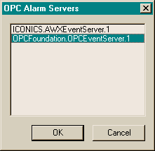
OPCFoundation.OPCEventServer.1 is the Sample Server described in the previous chapter.

Event Subscription
Now select Event Subscription from the OPC menu and check the Active box:
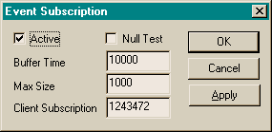
Event messages should now begin to fill the left pane of the main window. The right pane is a log of all OPC Event calls to the server:
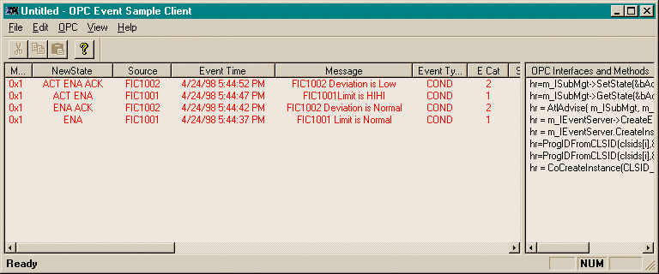

Get Status
Select Get Status from the OPC menu to view the server status:
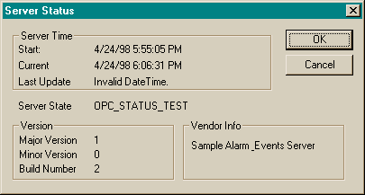

Language
Select Language from the OPC menu to excersize the OPC Common functions SetClientName() and Get/Set LCID.
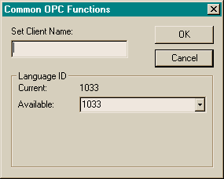

Browser
Select Browser from the OPC menu browse for Areas and Sources:
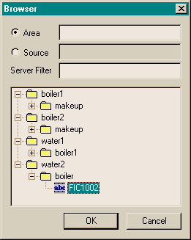

Filter
Select Filter from the OPC menu to get/set a filter for the active subscription
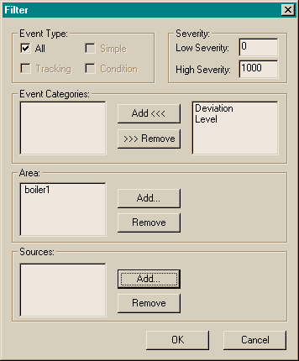

Attributes
Select Attributes from the OPC menu to select Event Attributes to be returned with each event. The first 20 subscribed attributes are displayed in the last 20 columns of the main (left pane) display.
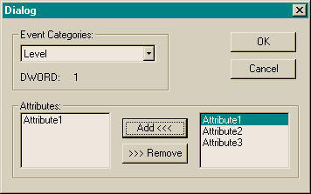

Source Code
The source code for the Sample Client is installed in the directory AlarmEvents\SampleClient the MSVC 5.0 workspace file (SampleClient.dsw) is used to load and build the project. The sample is an MFC application that uses ATL for all COM related calls. Smart pointers are used (derived from _com_ptr_t) to make the COM calls to the OCP Event Servers. The smart pointers for the OPC interfaces are created by importing the OPC type libraries using the following code in stdafx.h:
#import "opc_aeps.dll" exclude("_FILETIME")
using namespace OPC_AE;

#import "opccomn_ps.dll" exclude("_FILETIME")
using namespace OPCCOMN;

Much of the OPC related code is in the MFC Document Class (SampleClientDoc.cpp)

Proxy/Stub
The source code for the Alarm & Events proxy/stub DLL is in the directory AlarmEvents\proxy. The associated dsw files will compile the idl source file with the MIDL compiler and compile and link the resulting C source to produce the proxy stub DLL. The DLL also contains its type library embedded as a resource for easy import into projects that use the interface.
Note: The source for the proxy/stub is included for completeness only. The released version of the proxy/stub DLL is installed and registered as part of this installation. It is not necessary to build this project from source. UNDER NO CIRCUMSTANCES SHOULD THE IDL FILE BE MODFIED IN ANY WAY.

